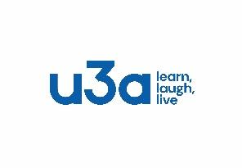 | Arnold u3a  NEW MEMBER  Nov 1st 2025 - Oct 31st 2026 | Membership No  (Leave blank)

Please write clearly in BLOCK CAPITALS
Title: | First name: |  |  | Surname:
Address:  Postcode |  |  |  | Mobile:  Home phone:
Email address:
Membership Subscriptions
Annual £15.00  From May 1st £ 9.00  From Aug 1st £ 6.00 |  | £11.00 if member of another u3a and paying the full fee to that u3a. If so, please supply the name of the primary u3a and membership no of that u3a
Ways to pay (please tick)
Cash ☐ |  | Cheque (Arnold u3a) ☐ |  |  | Bank Transfer ☐
Bank Transfer details
Sort Code 08-92-99 |  | Account No. 67223118 | Account Name:  Arnold Univ of Third Age Fee Acct
Please answer either Y or N by circling appropriate
I consent to my data being used for membership purposes |  |  | Y | N
I wish to receive the free Third Age Trust magazines |  |  | Y | N
I consent to Arnold u3a reclaiming tax on my membership subscription* (see below) |  |  | Y | N
Title | First name | Surname
Signature |  | Date
GIFT AID
* If you pay income or capital gains tax we can claim this back from the Government in Gift Aid. Tax can only be claimed by circling YES and signing the form.
Please notify Arnold u3a if you wish to cancel this declaration, change your name or address, or no longer pay sufficient tax on your income.
Please return the completed form to: Cathy van Baalen, Membership Secretary Arnold u3a
30 Melbury Road, Woodthorpe, Nottingham NG5 4PG
Email: arnoldu3a.membership@gmail.com or at any monthly membership meeting

For internal use only - NEW MEMBER
Members Name:
Method of payment: | Amount paid:
Membership Secretary signature: | Date:

