How to update your Group details on Beacon
When in the website arnoldu3a.org,
Hover over Beacon and click on ‘SYSTEM USER’
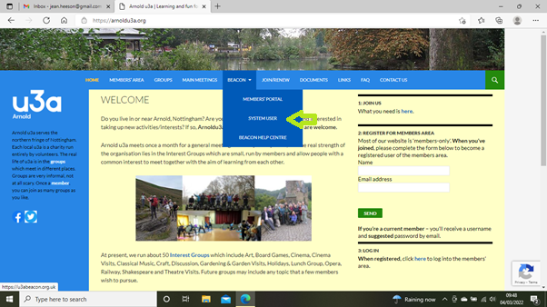
Login using – Arnold
Username - (your name in lower case with no space between forename and surname)
Password – (this will be a temporary password if it is your first sign on)

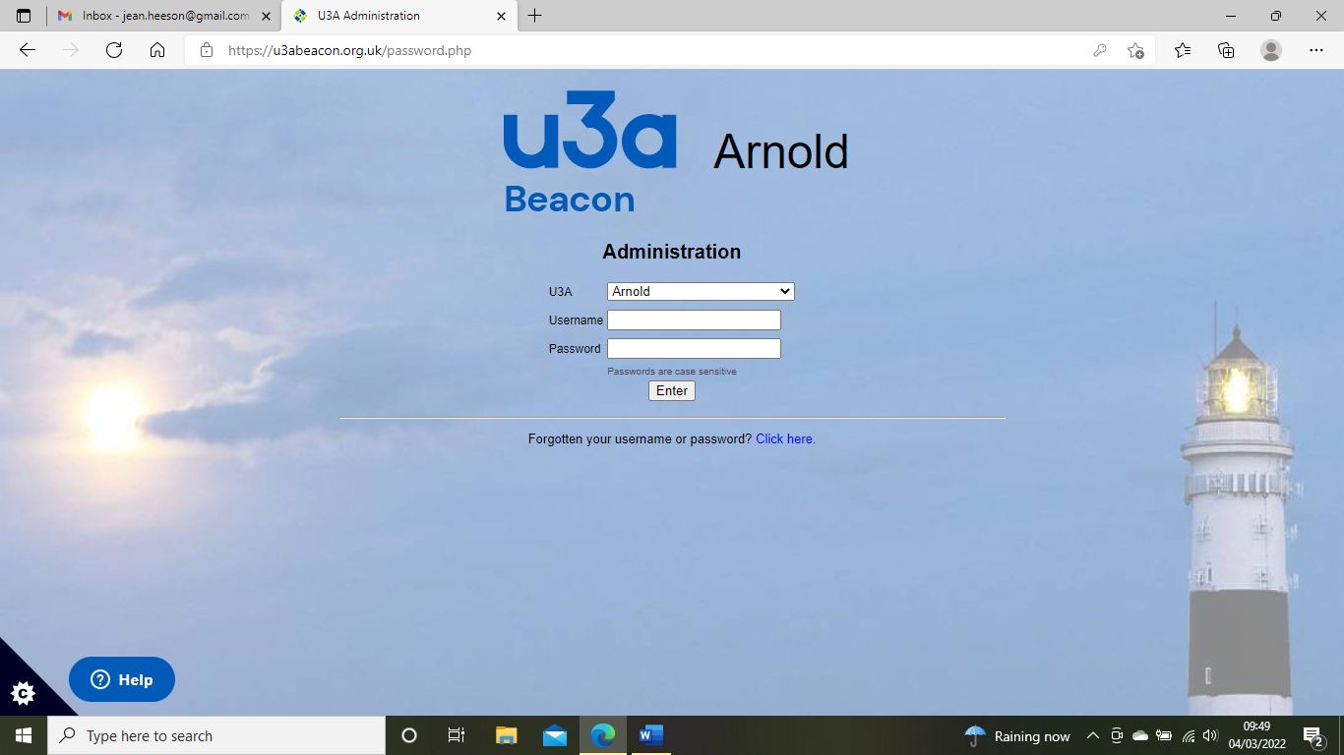
The next screen will be asking you to create your own password. When you enter this, you will get the beacon home screen.

Beacon Home screen. (Please ignore any messages from Beacon below the yellow part.)
Click on ‘Groups’
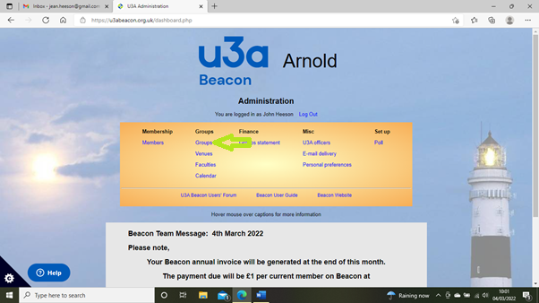

Scroll down to your group and click on its name in the Group column.
(do not tick the box)
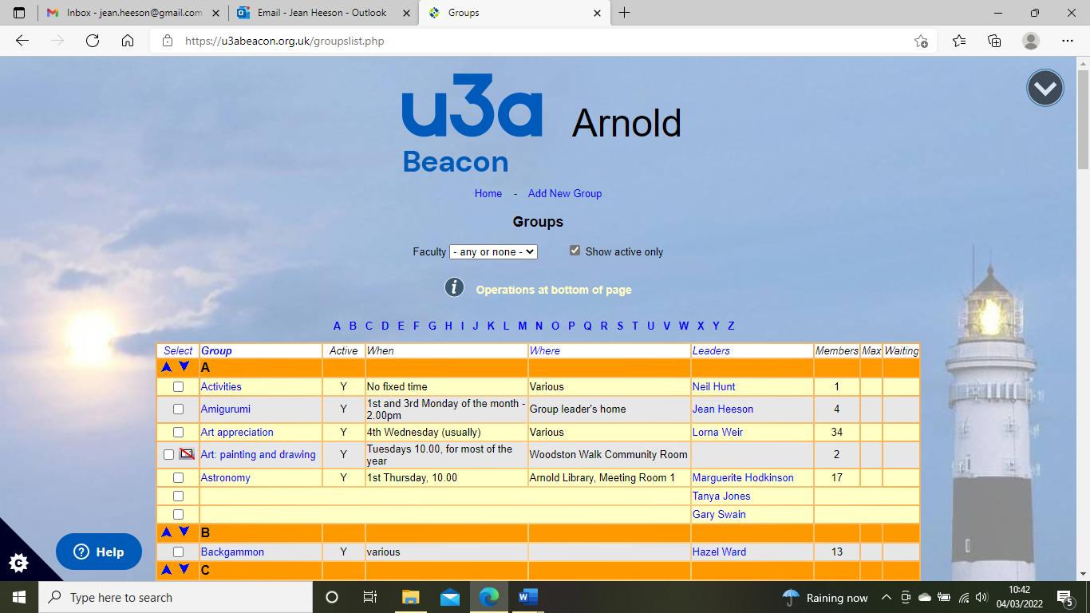

You then have a choice of 4 actions:
Details - this information is displayed on the ‘GROUPS (PUBLIC)’ page.

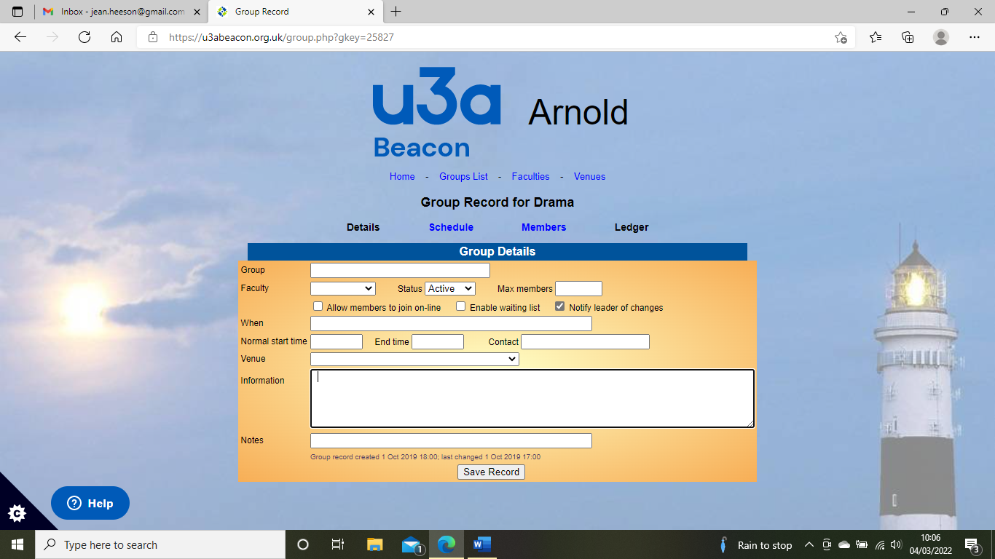
Enter details which are highlighted in Green. When you hover over some of the boxes, with your curser, a black box may appear explaining what to enter in the box.
Group - will already contain your group name
Faculty – leave blank. Status – Active Max Members – you can enter this
Allow members to join on-line Enable waiting list Notify leader of changes
When – enter what day you meet. e.g. 1st & 3rd Monday of the month
Normal start time End time Contact – your name
Venue – click the box to see a drop-down list of venues
Information – whatever info you wish to be published in the Groups list when displayed on the website

Schedule - these details will be shown on the ‘CALENDAR ’ in the
members’ website area.
Enter details and click ‘Add Events’ and the date will appear on the list. You can then add more dates or delete ones that have been cancelled.
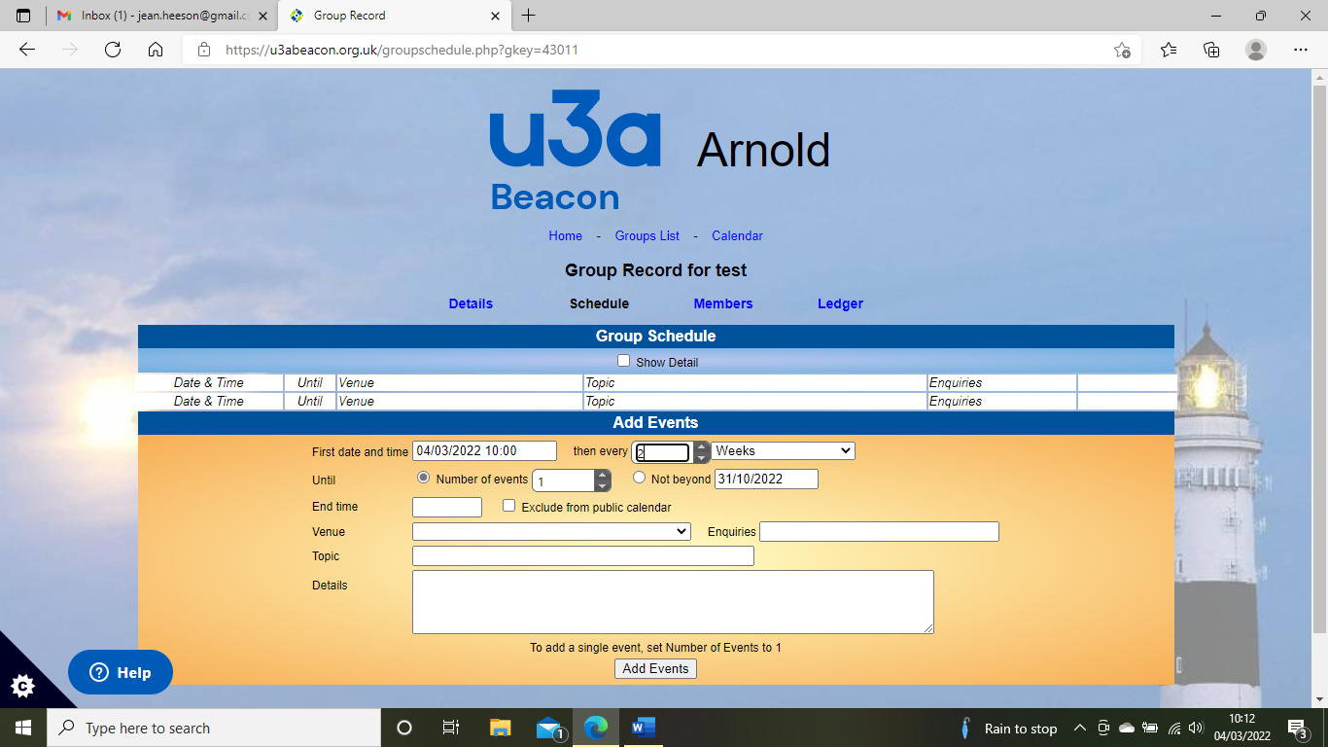
Enter first date and time. You can then select ‘then every’ ‘X’ no. of days, weeks or months.
You can then enter ‘number of events’ OR ‘not beyond a certain date’.
Enter - End time, Venue – click the box to see a drop-down list of venues, Enquiries – email or phone number. You then can leave the rest blank if you wish.
This part of beacon is not very user friendly and you cannot enter, for example 1st and 3rd Monday of the month. You will have to enter the first date, every 1 week not beyond dd/mm/yyyy and then press ‘Add Events’ A list of all the dates will appear at the top and you will then have to click ‘delete’ on the ones you don’t want.
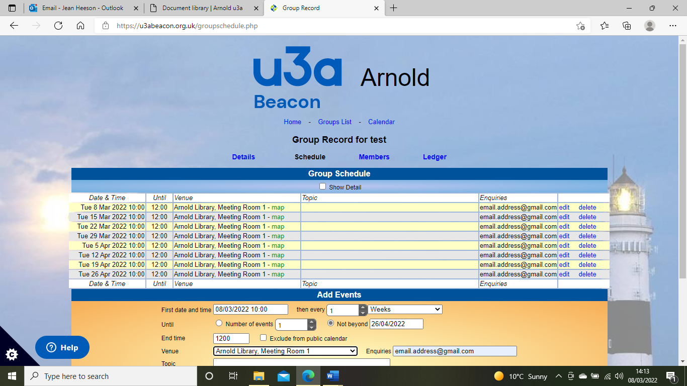
This is the Beacon Calendar
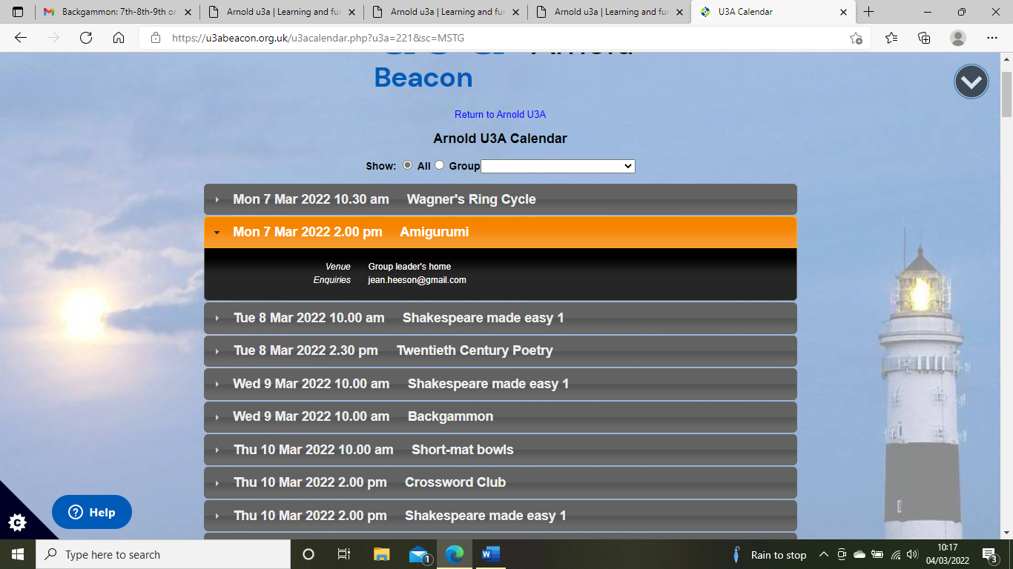

Members - this is where you can add new members to your group and send
emails via Beacon.
To add a member, click on the ‘select member’ tab and the full list of members will appear to enable you to find and select their name. Then click ‘ADD’ and their details will appear.

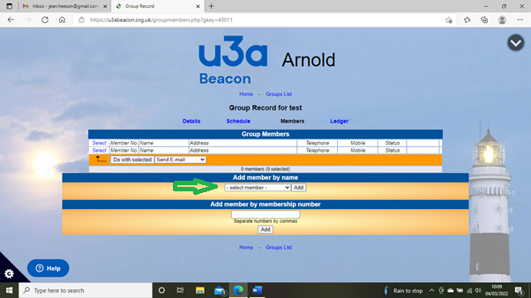

To send emails, select each member that you are sending it to, by ticking the box next to their name, then Click ‘Do with selected’ tab at bottom of list.

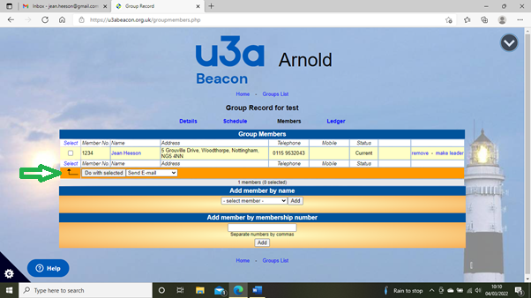

Type in Subject and then text of email.
Click ‘Send’.
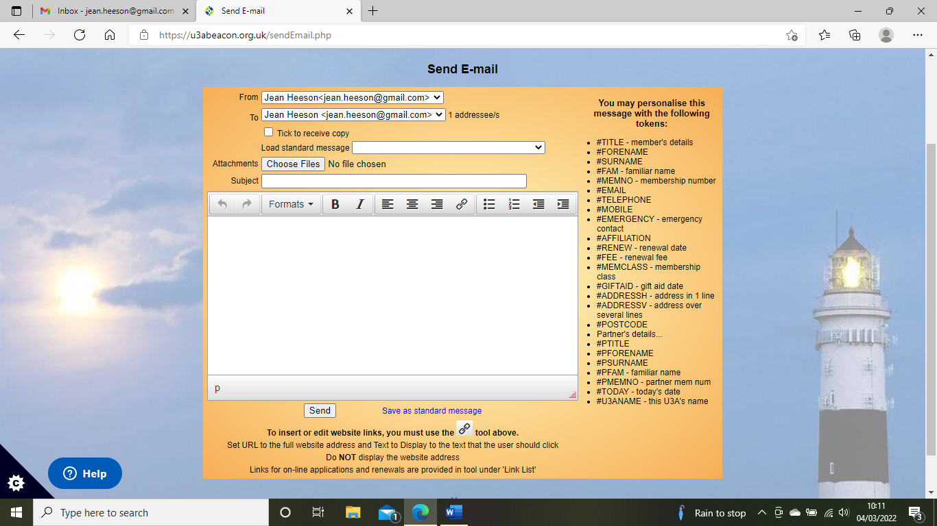

Ledger - this is where you can keep track of money in and out.
